Tenis Mizuno Wave Dimension
$2,899.00
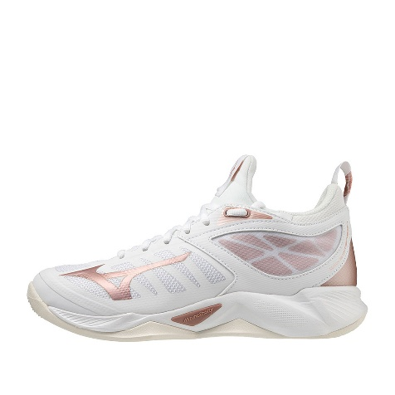
Tenis Mizuno Wave Momentum 3
$3,399.00

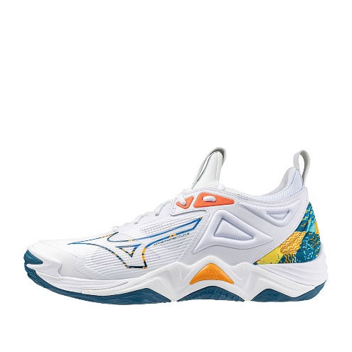
Tenis Mizuno Wave Momentum 3 Mid
$3,499.00
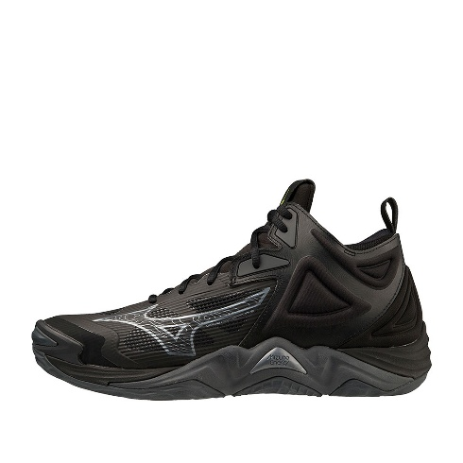

Tenis Asics Upcourt 6 GS
$1,899.00
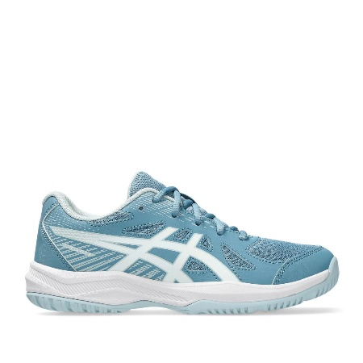
Tenis Asics Netburner Ballistic FF 3 Paris
$3,499.00
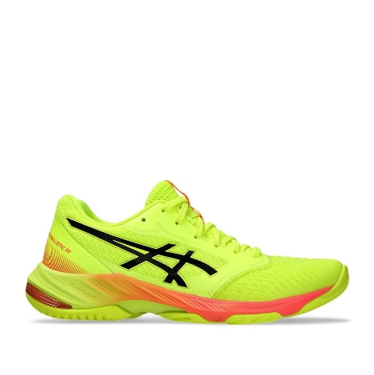
Tenis Mizuno Wave Dimension
$2,899.00

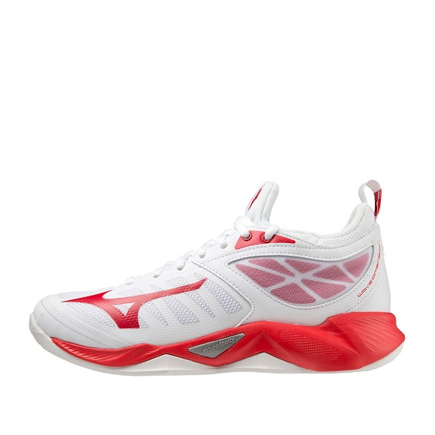

Tenis Mizuno Wave Momentum 3
$3,399.00
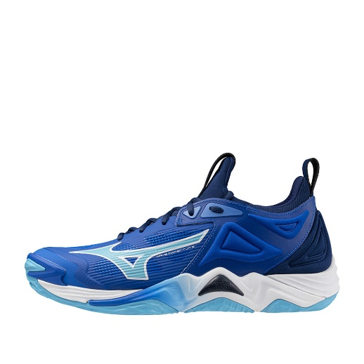
Tenis Mizuno Wave Momentum Elite
$3,799.00

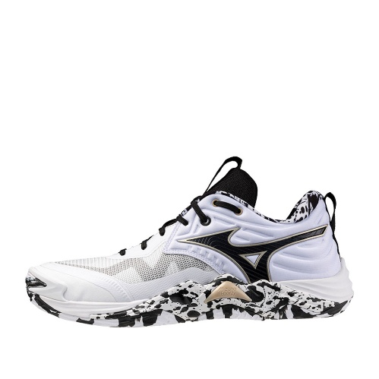
Tenis Asics Gel Rocket 10
$1,799.00

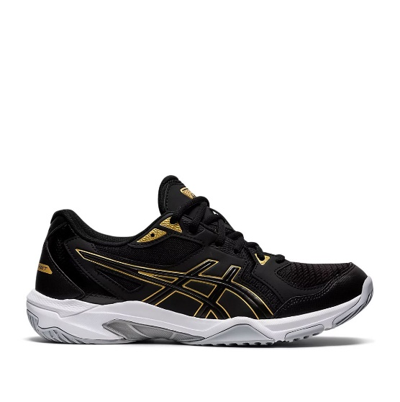

Tenis Mizuno Neo Jump
$3,899.00
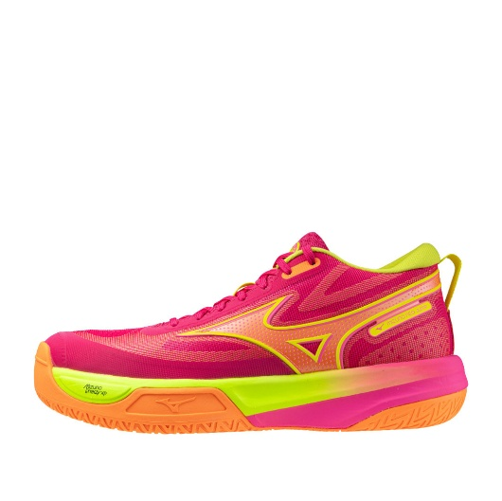
Tenis Mizuno Wave Momentum 3
$3,399.00
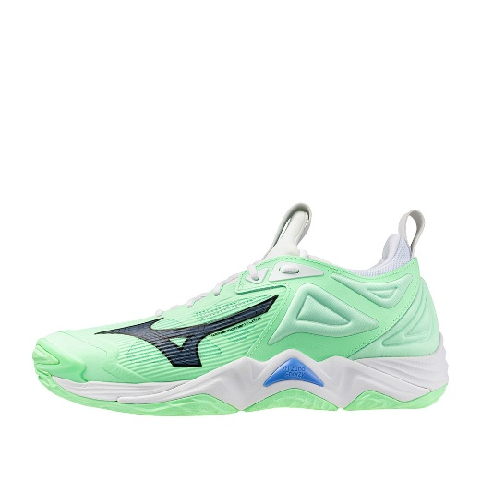
Tenis Mizuno Wave Momentum 2
$2,499.00

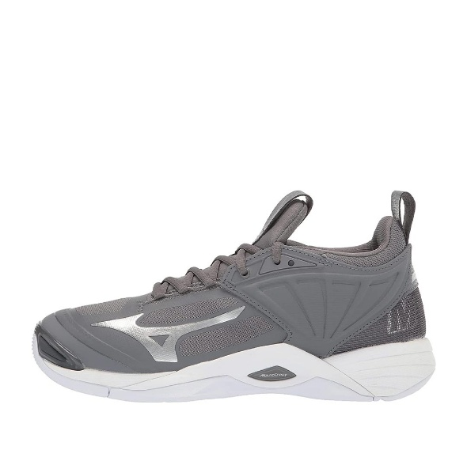

Tenis Mizuno Wave Momentum 2
$2,499.00
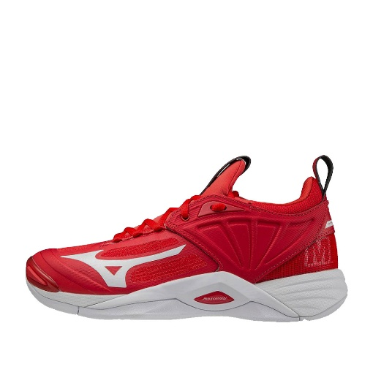
Tenis Asics Upcourt 6 GS
$1,899.00
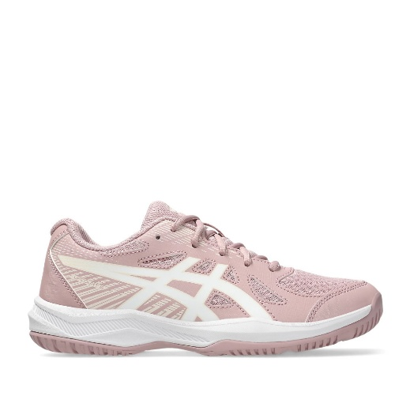
Tenis Mizuno Wave Momentum Elite
$3,799.00

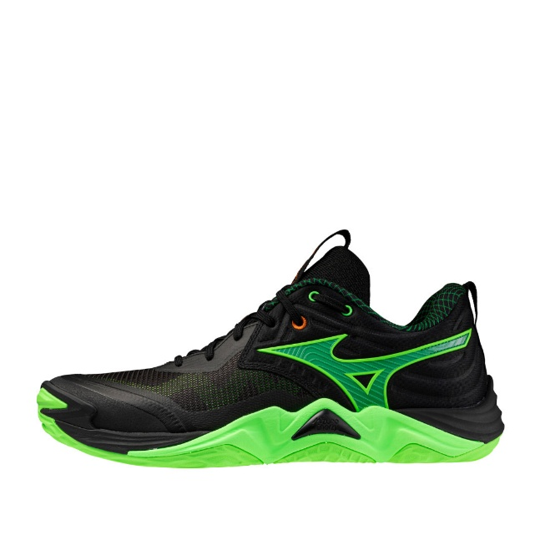

Tenis Asics Gel Rocket 11
$2,099.00
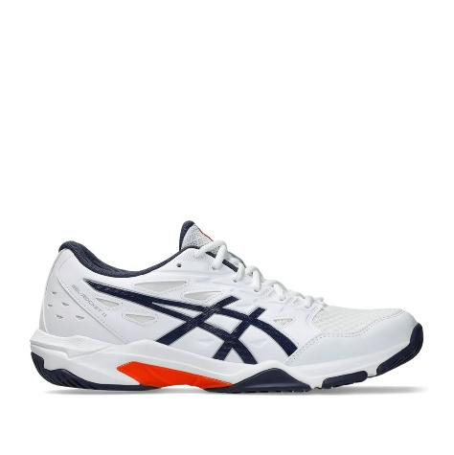
Tenis Asics Upcourt 5
$1,799.00
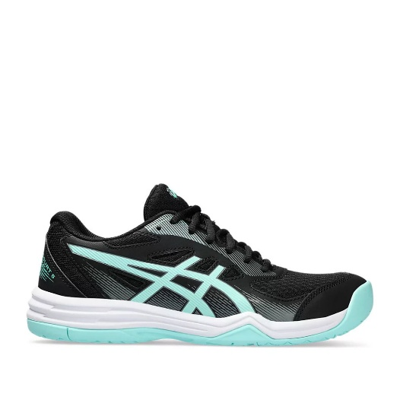
Tenis Mizuno Wave Momentum 3
$3,399.00

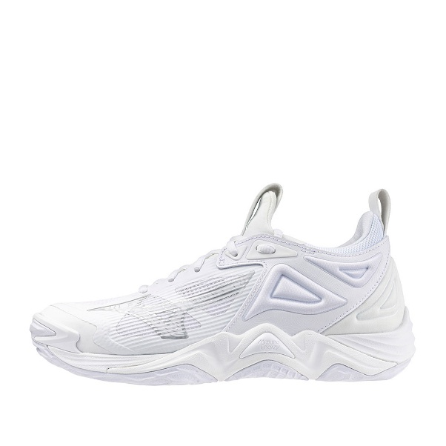

Tenis Mizuno Wave Lightning Z4
$2,249.00
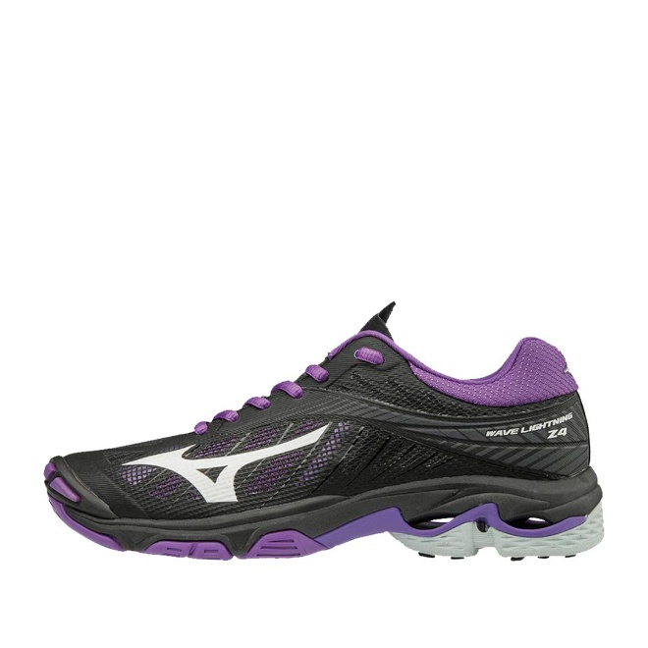

Tenis Asics Upcourt 6 GS
$1,899.00
